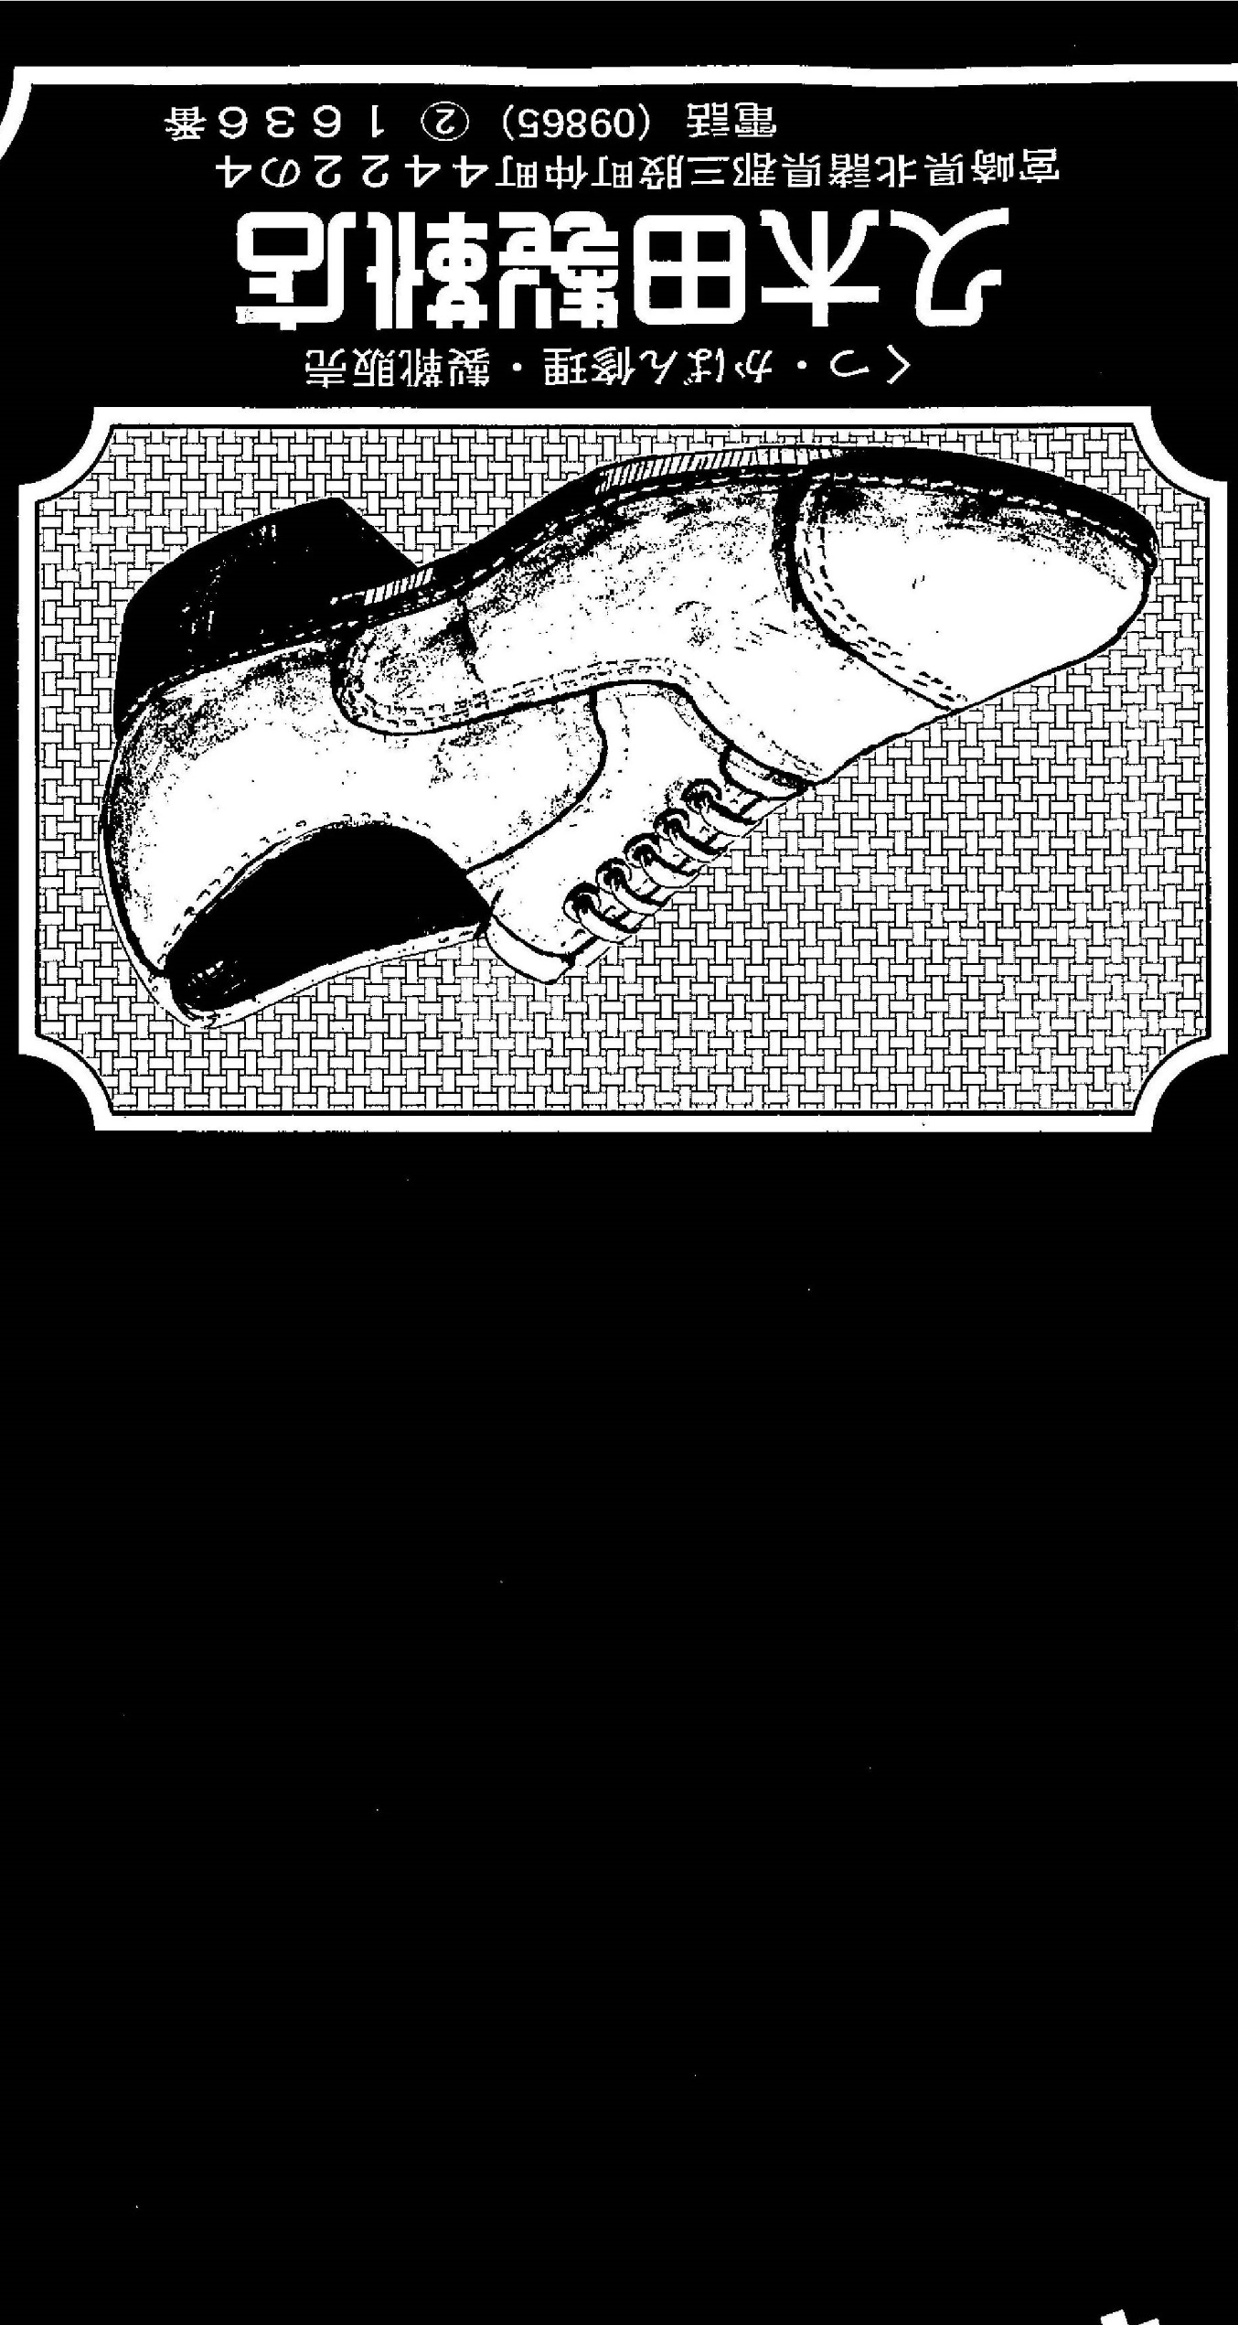

Ｈａｎｄｍａｄｅ　Ｌｅａｔｈｅｒ　Ｃｒａｆｔ

ＫＵＫＩＴＡ