*hand sewing*

*Tom*

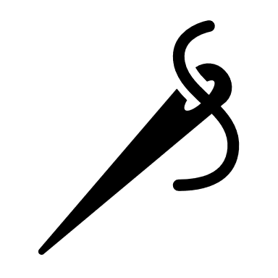

***Handmade Leather craft***